MODULE 4 CSS AND CSS3

Q-1 WHAT IS THE ADVANTAGES OF USING CSS?

* we can diffrent effect the one file for using css
* We can run a whole website in one programme.
* Css is cut the file in small file.
* In css we can diffrent effect a one file.

Q-2 WHAT IS THE DISADVANTAGES OF USING CSS?

* the css is a not support all style sheets.
* Css different types like (css css2 css3) so we can it all type different so it can be lengthy for understood.
* In the css lack of security

Q-3 WHAT IS THE DIFFERENT BETWEEN CSS2 AND CSS3?

css2 a superset in css2 number of new capabilities like absolute, relative, fix position of element. Or support for style sheet shadows, border, new font etc. But in the css2 some errors and some poor support.

Css3 the css3 is support the many browser of css 2 but be sure to test in all operating system and browser.

In css new feature added

* Pseudo elements
* New css selector
* New style properties

Q-4 NAME A FEW CSS STYLE COMPONENTS?

A-4 inline css

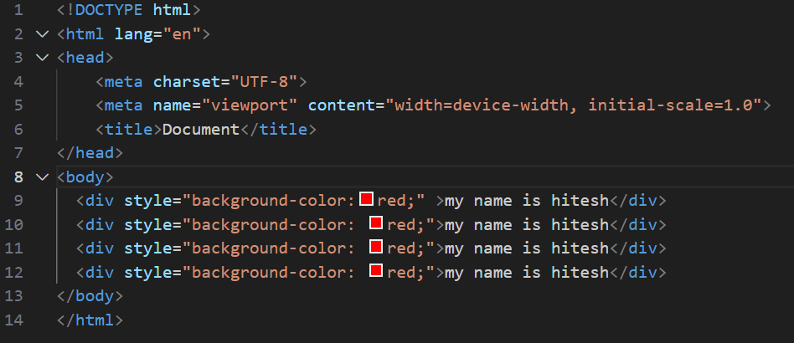

Internal css

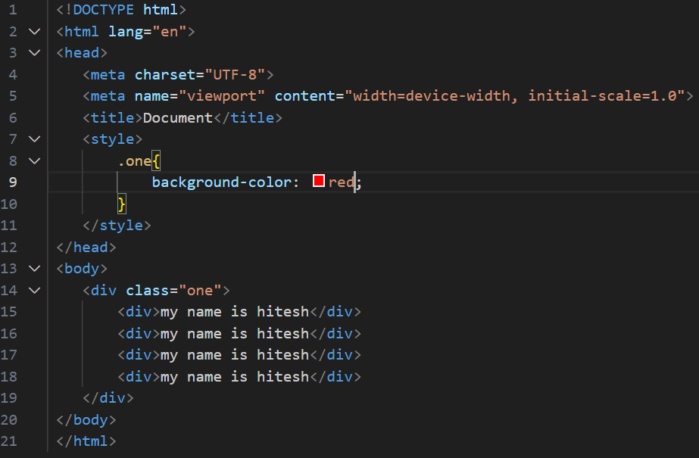

External css

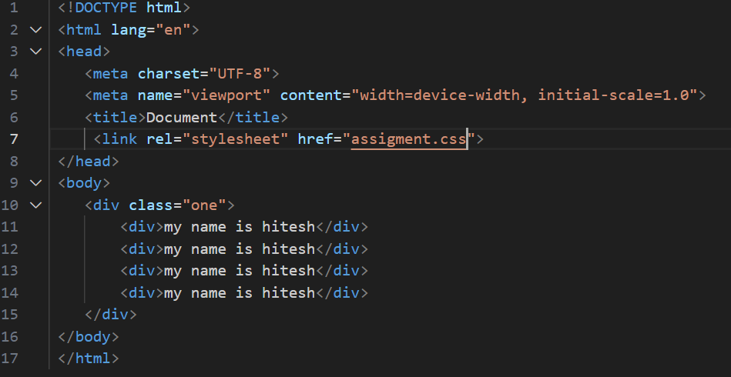

Q-5 WHAT DO YOU UNDERSTAND BY CSS OPACITY?

A-5 the css opacity is a transparency the programme

Opacity value is a o to 1 degree

Example

Css opacity

0.3

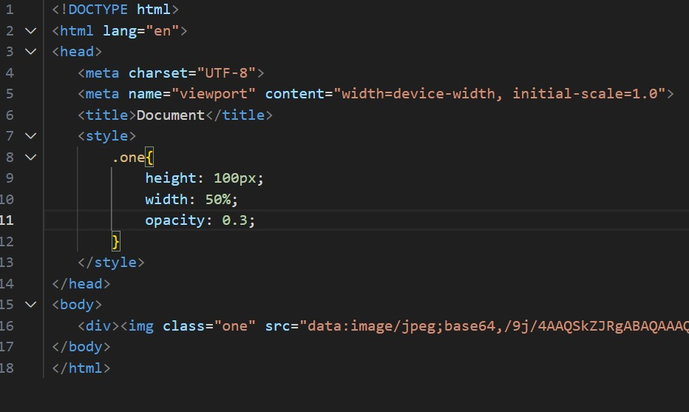



Css opacity

0.5

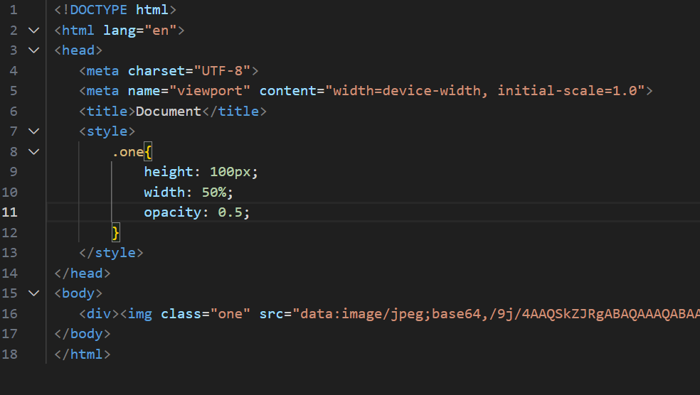



Css opacity

1

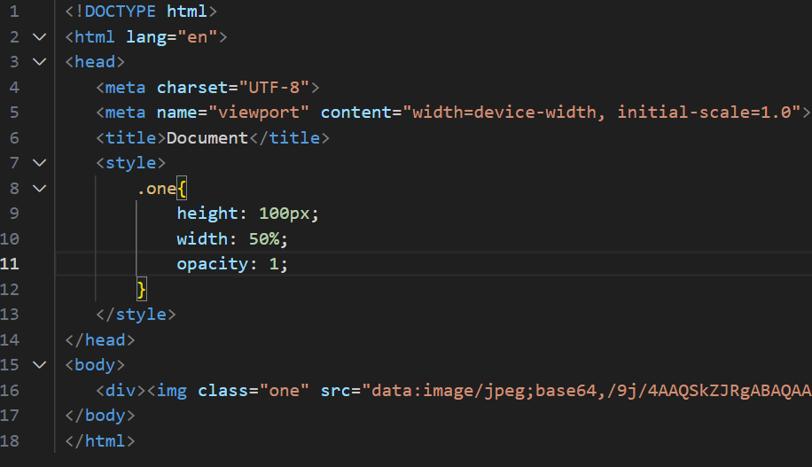



Q-6 HOW CAN THE BACKGROUND COLOUR OF ELEMENT BE CHANGED?

A-7 use the css property background color and changed the background color

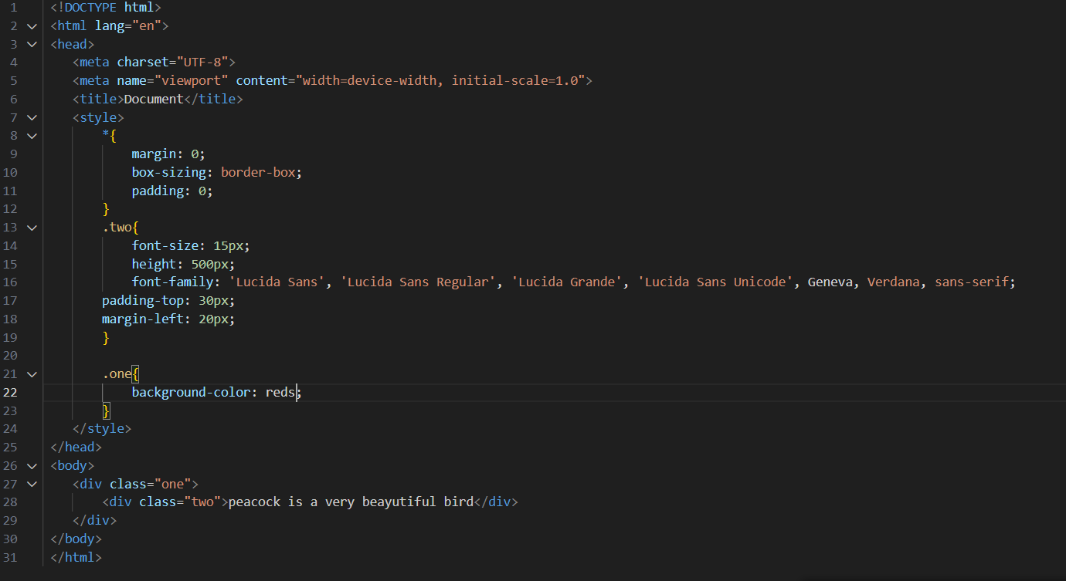

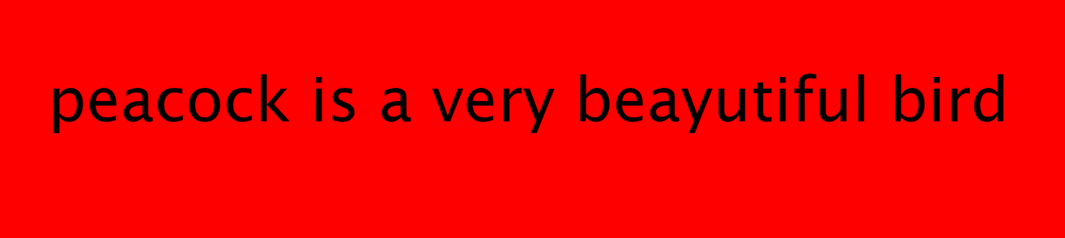

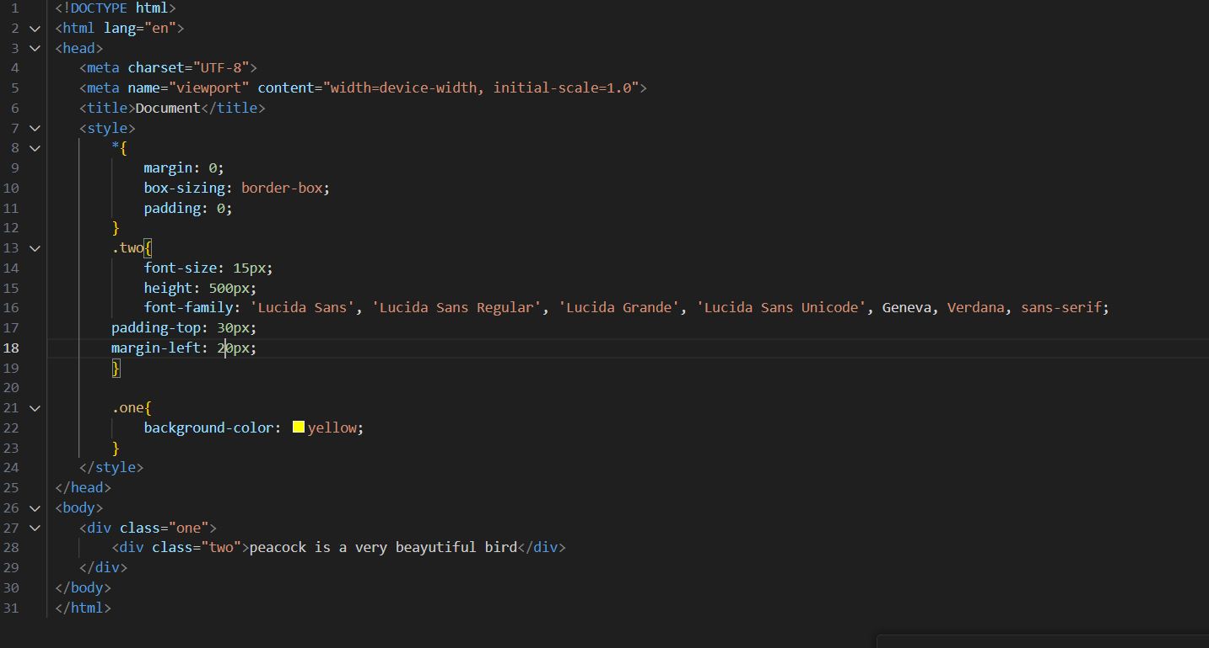



Q-7 HOW CAN IMAGE REPETATION OF THE BACKUP BE CONTROLLED?

A-7 use the css background repeat “no-repeat “and we can image reptation backup be controlled

Normal image



Controlled repeat

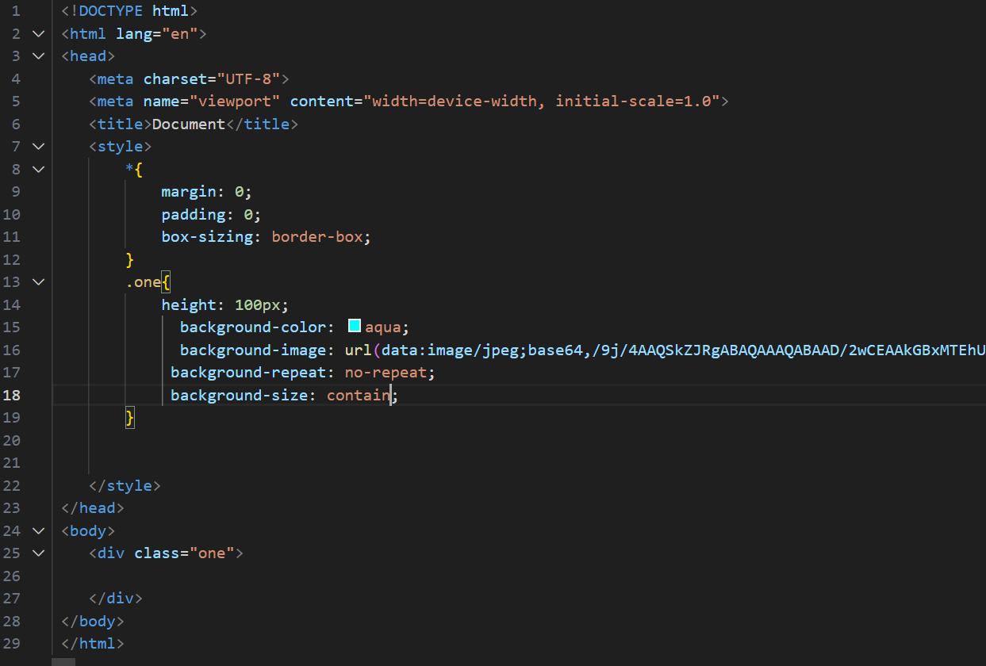



Q-8 WHAT IS THE USE OF BACKGROUND POSITION PROPERTY?

A-8 the background position is use the set starting position of back ground image

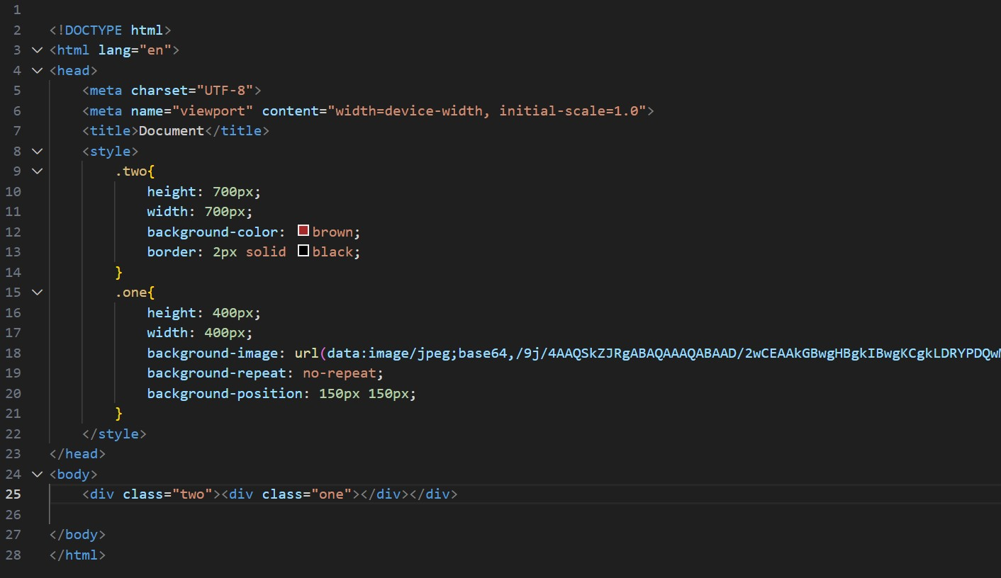

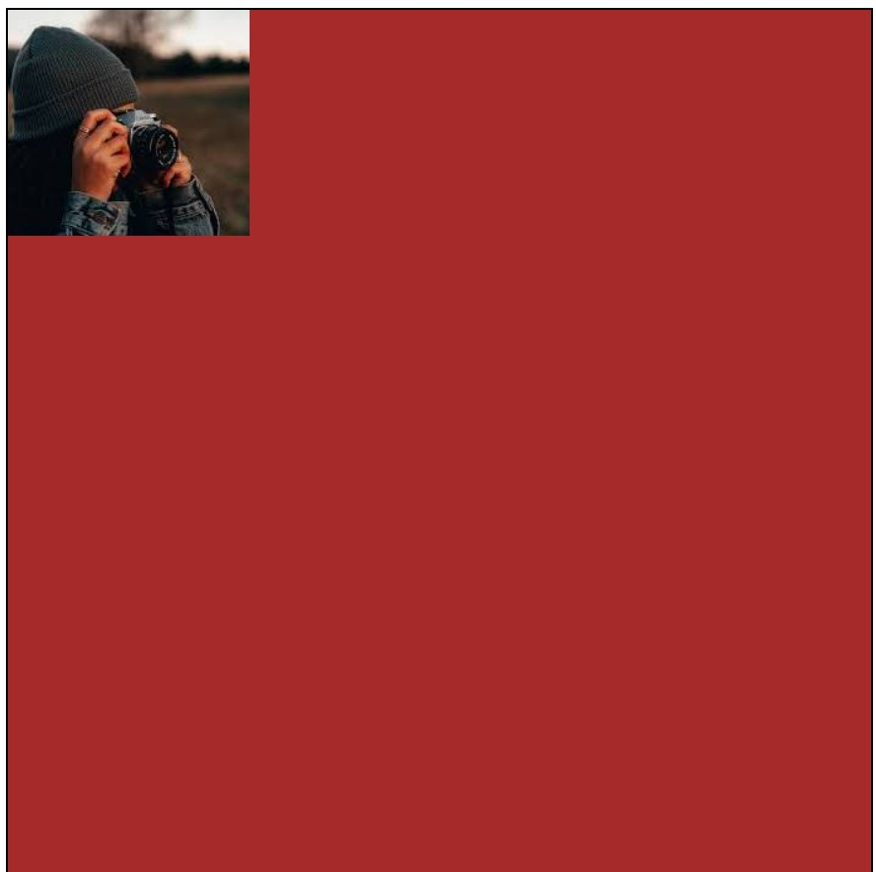

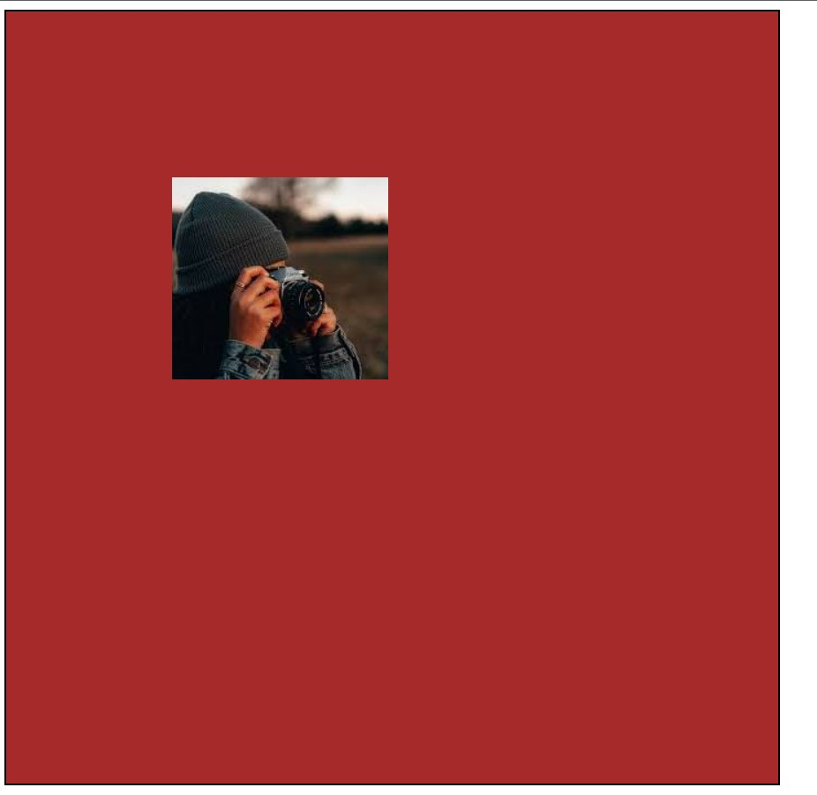

QUE-9 WHICH PROPERTY CONTROLL THE IMAGE SCROLL IN BACKGROUND ?

ANS-9 back ground image fixed is used in control the image scroll in background.

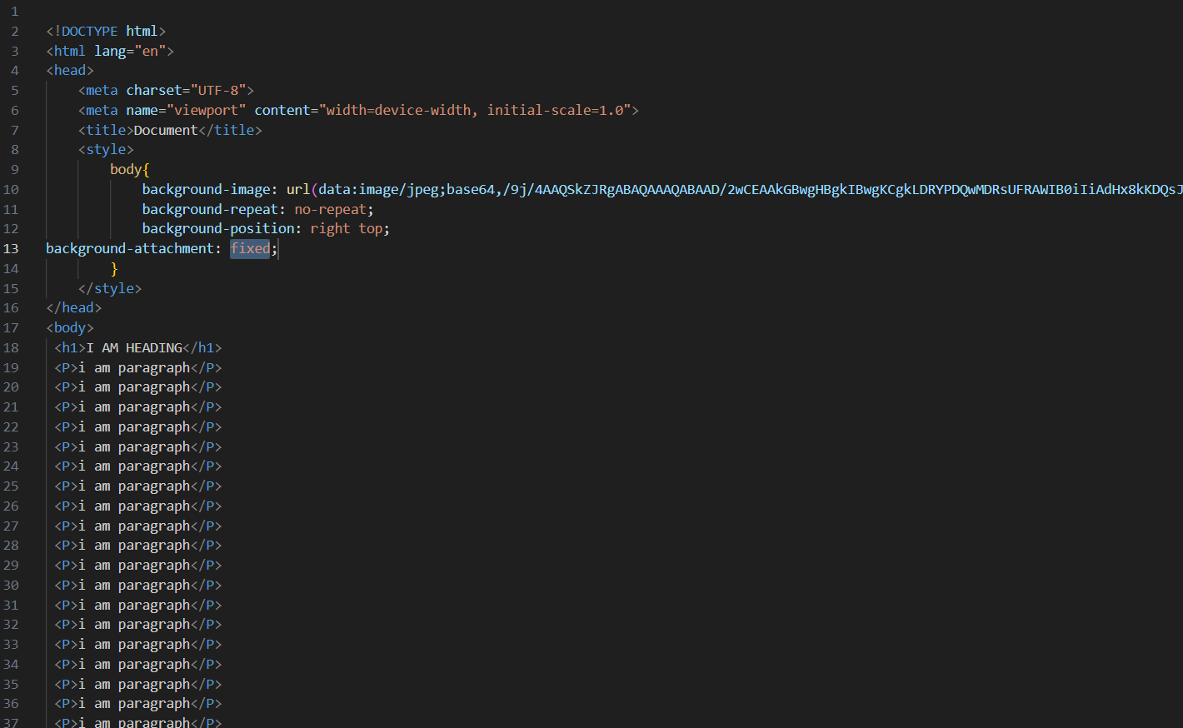

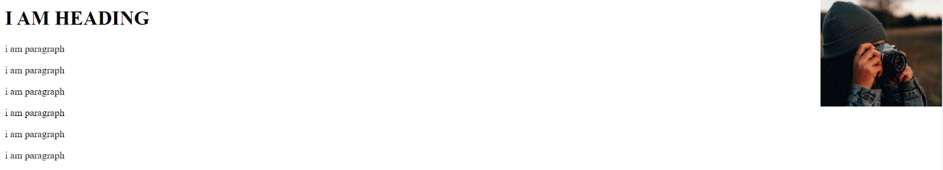

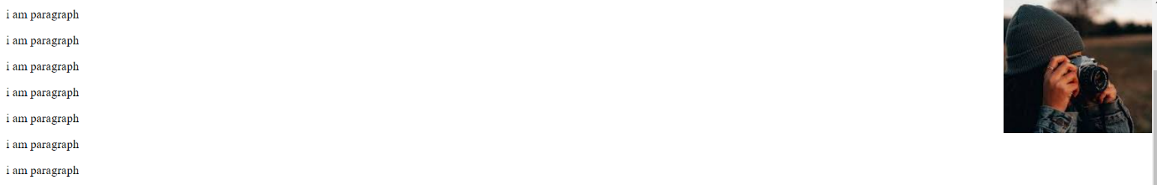

QUE-10 WHY SHOULD BACKGROUND AND COLOUR BE USED AS SEPRETE PROPERTIES ?

ANS-10 color is a inherited property while the background is a not.so we should background and colour be used a seprete properties.

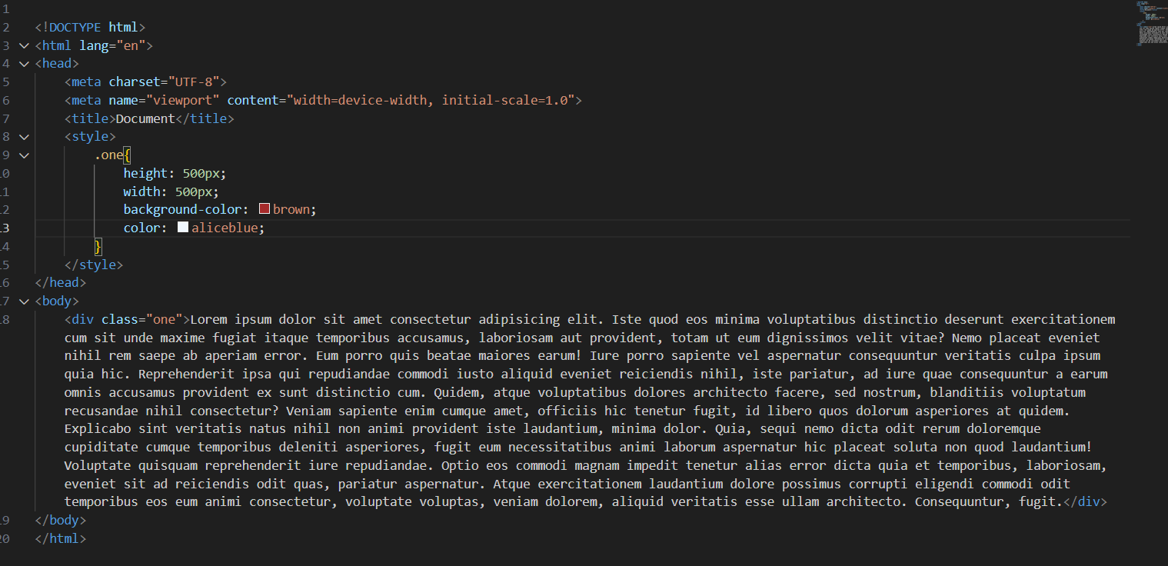

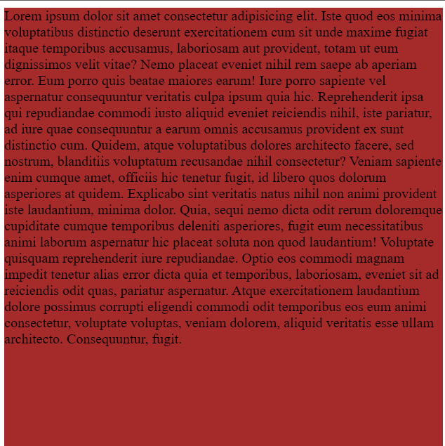

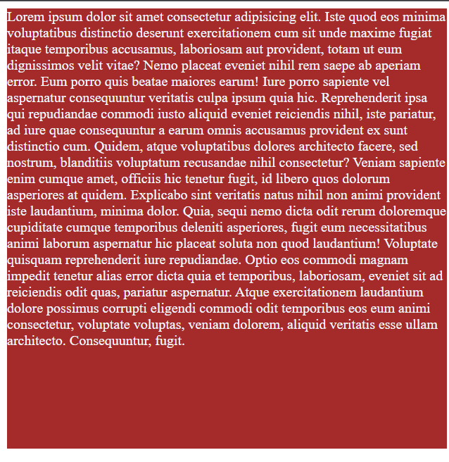

QUE-11 HOW TO CENTER BLOCK ELEMENT IN CSS1?

ANS-11 justify content or align item can be use of block element in center.

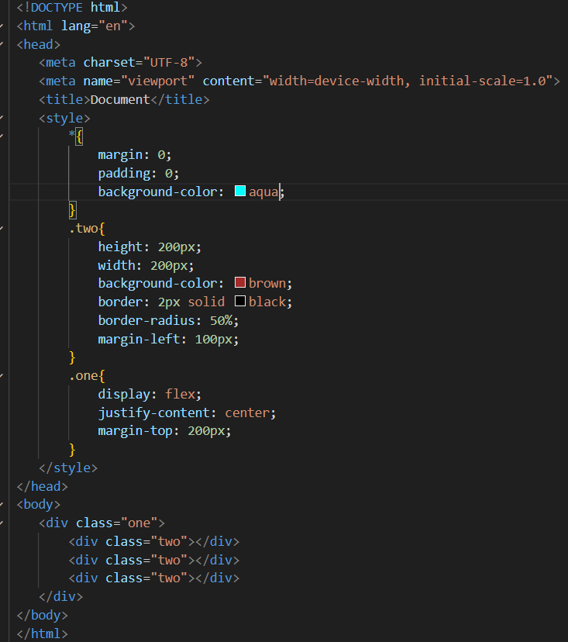



QUE-12 HOW TO MAINTAIN THE CSS SPECIFICATION ?

ANS-12 the css specification are maintained by the world wide web consortium.

There are three type specification

* Selector-main
* Property-background-colour
* Value-aqua

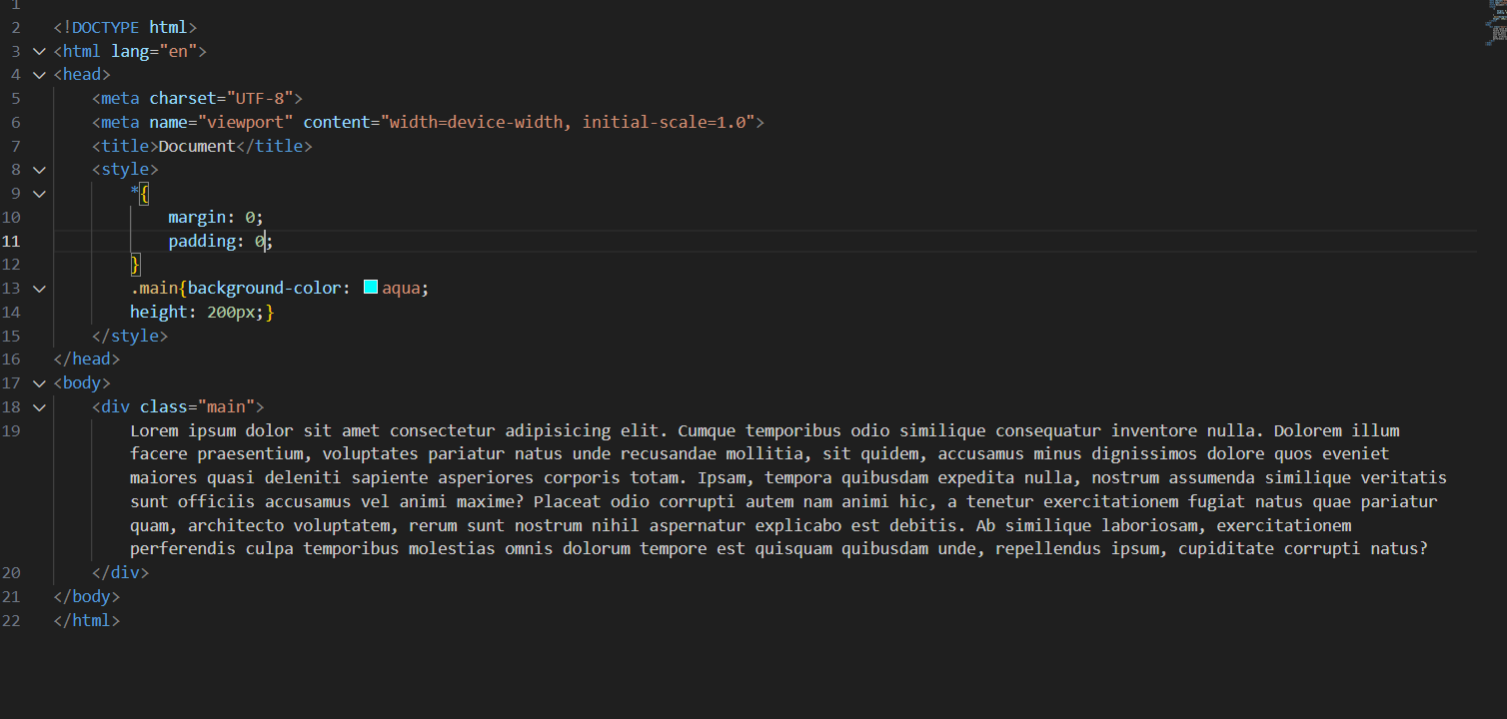

QUE-13 WHAT ARE THE WAYS TO INTEGRATE CSS AS A WEB PAGE ?

ANS-13 there are three ways to integrate css as a web page

* Inline css
* External css
* Internal css

Inline css

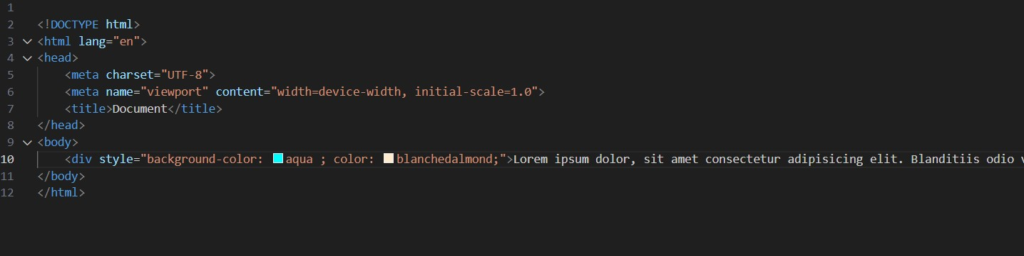

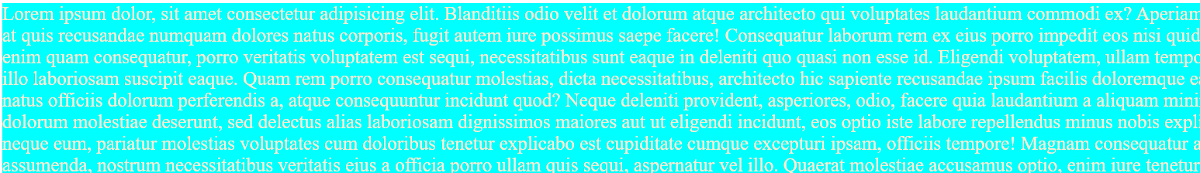

Internal css

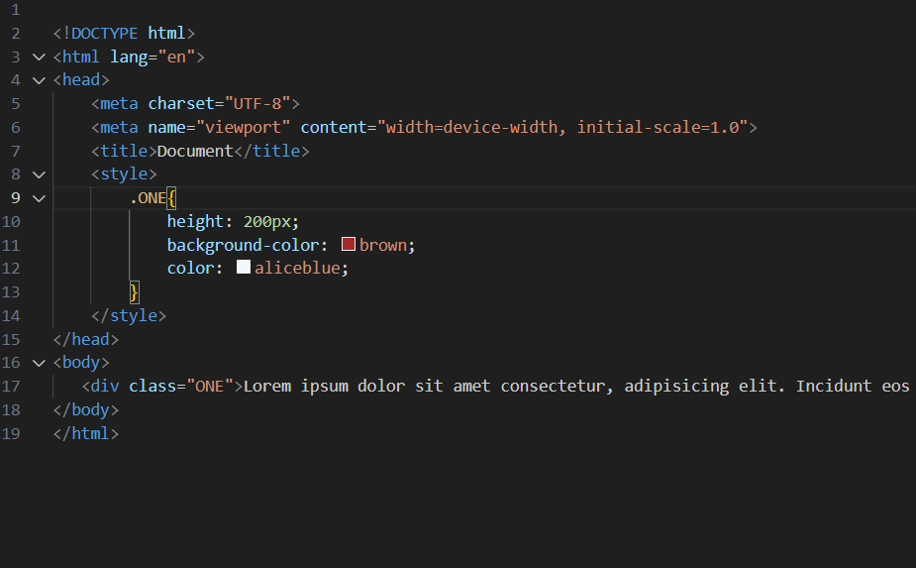

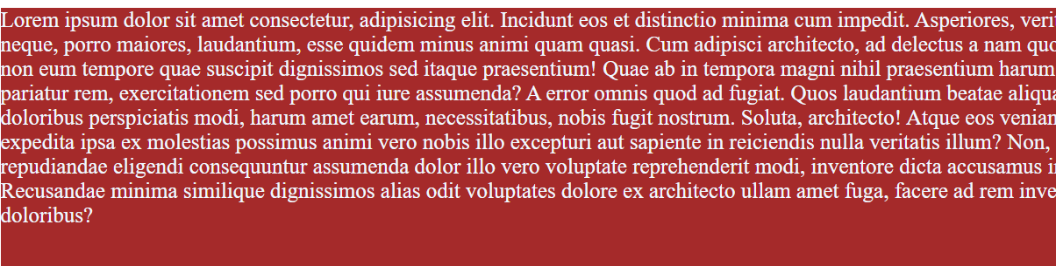

External css

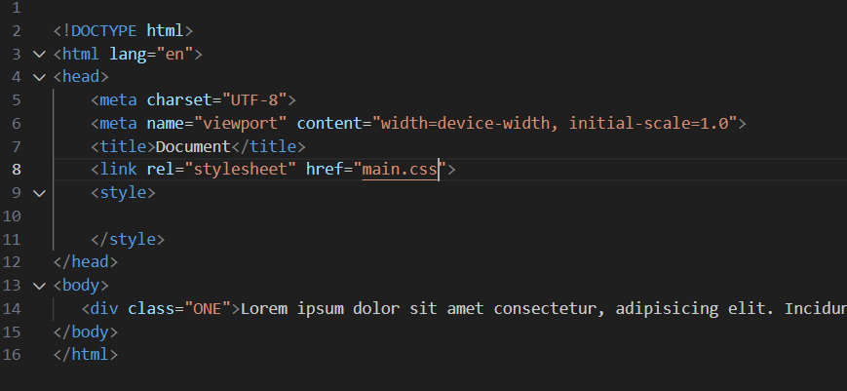

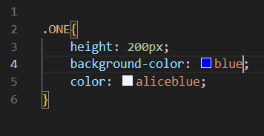

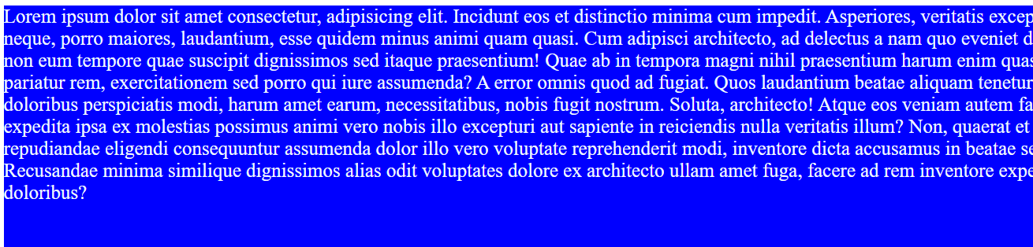

QUE-14 WHAT IS EMBEDDED STYLE SHEETS?

ANS-14 an embedded style sheet is declared within the <head> element of an xhtml document

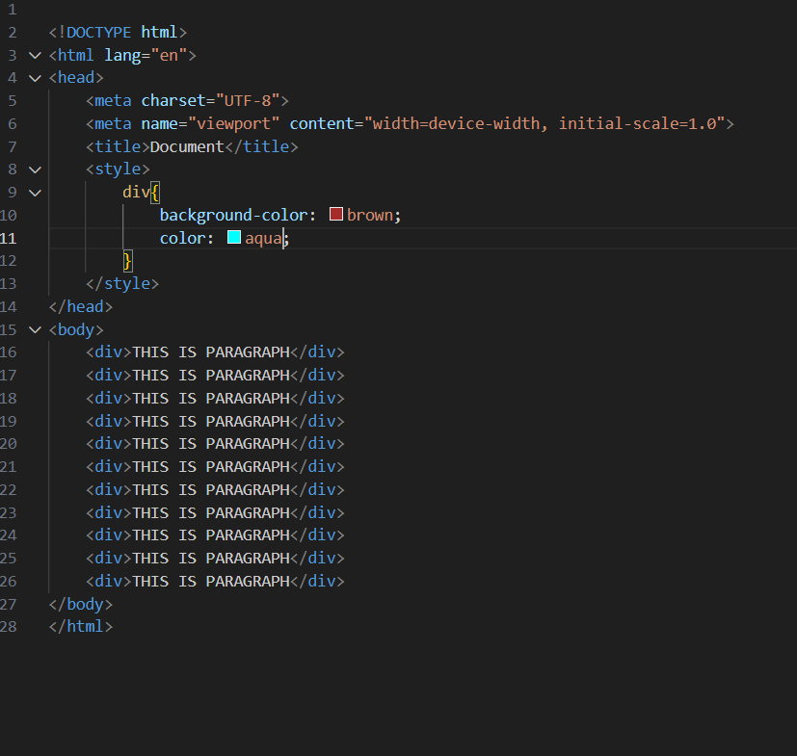



QUE-15 WHAT ARE THE EXTERNAL STYLE SHEET?

ANS-15 an external style sheet is a seprete css file that can be exceed by creating a link within the head section of a web page.

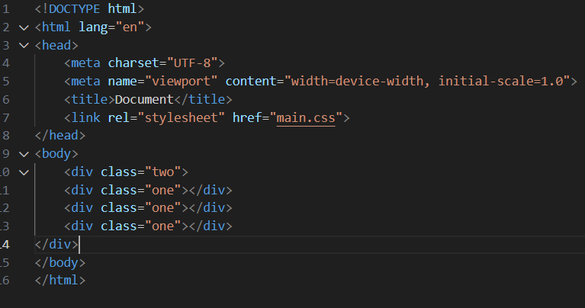

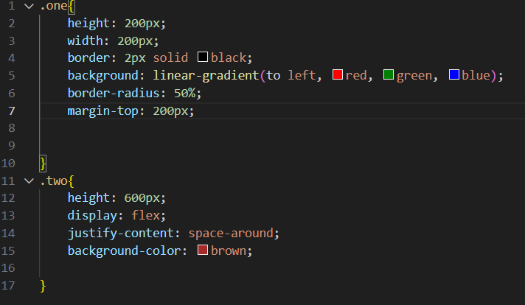



QUE-16 WHAT ARE THE ADVANTAGE OR DISADVANTAGE IS EXTERNAL CSS ?

ANS-16

ADVANTAGE

* One change to style sheet will change all link page
* You can create classes of style sheet that can then be used on many different html elements
* Constituent look and feel across multiple wab page

DISADVANTAGE

* Your pages not be renderd correctly until the external css is loded.
* Uploading or linking to multipal css file can increase your sites download time.

QUE-17 WHAT IS THE MEANING OF CSS SELECTOR?

ANS-17 when we can representation the any element it call selector.

In css two main selector

* .class
* #id

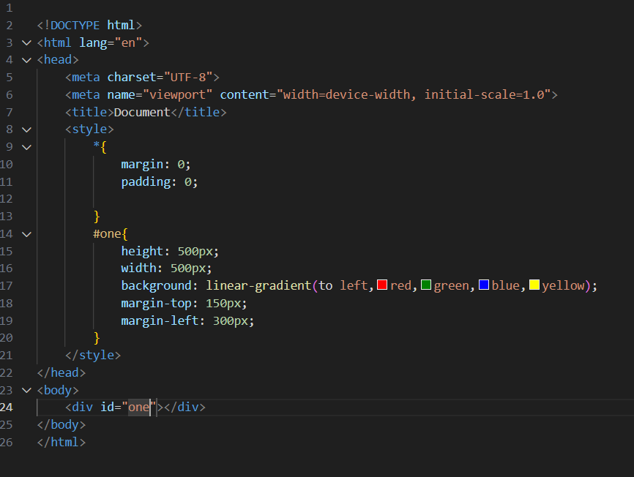

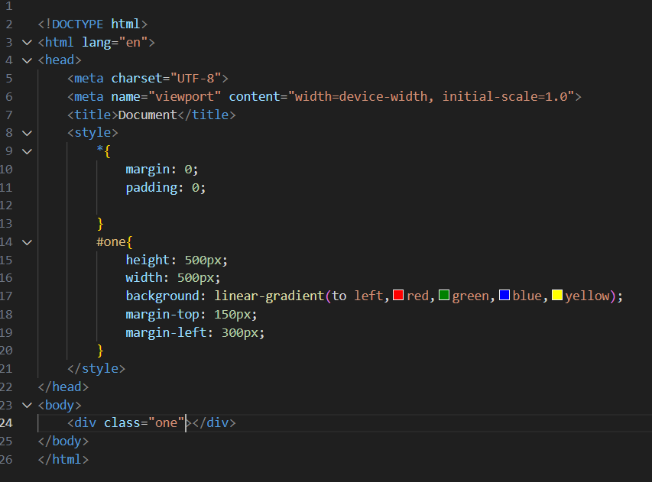

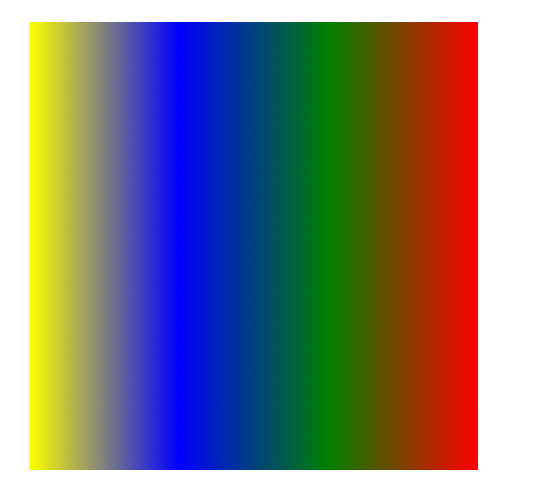

QUE-18 WHAT ARE THE MEDIA TYPLE ALLOWED CSS?

ANS-18 media types allow you to apply different style to different device or media types media types

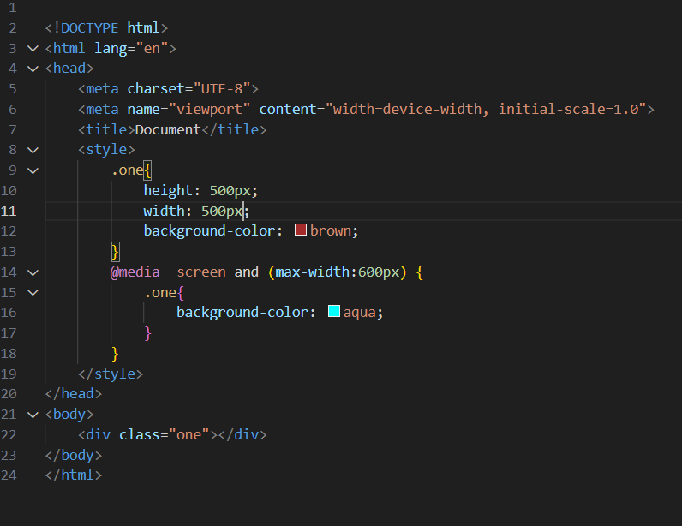

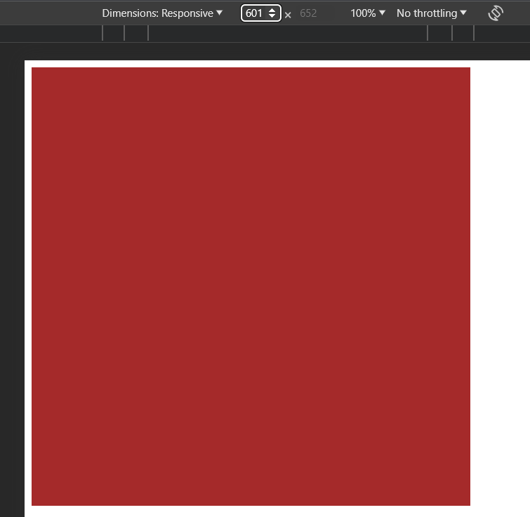



QUE-19 WHAT IS THE RULE SET ?

ANS-19 A table of instructions used by a controlled interface to determine what data is allowable and how the data is handled between interconnected systems.

RULE SET

* SELECTOR
* PROPERTY
* VALUE

